Escambia County Fire Rescue
Training Division
2026 Calendar
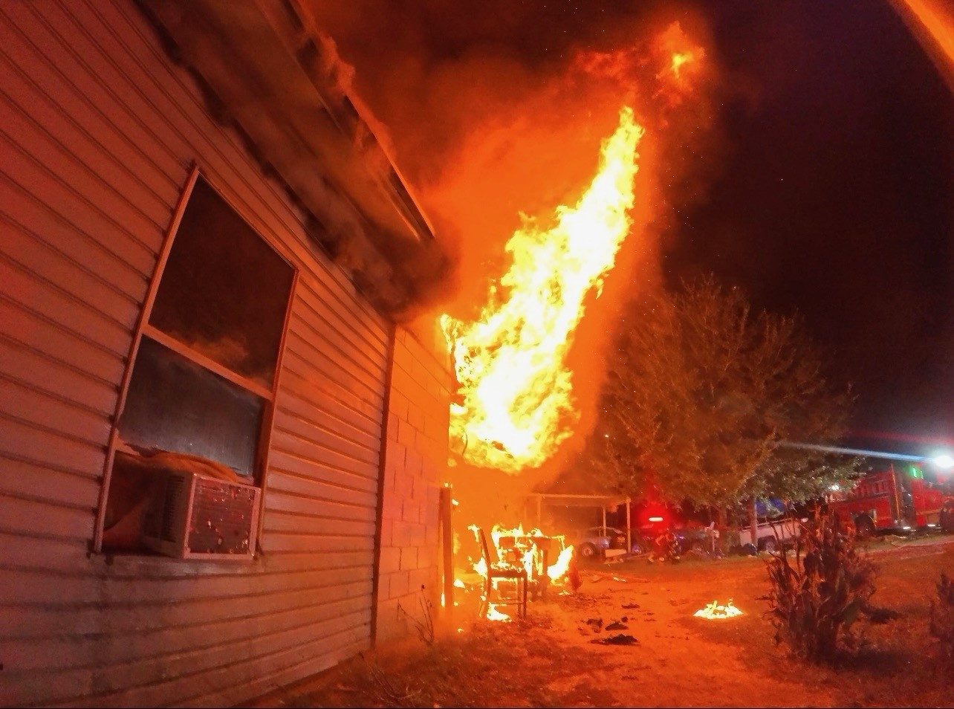

Escambia County Fire-Rescue is committed to providing effective and efficient fire-rescue services that meet the community’s needs in life protection, property conservation, preservation of the environment, and fire prevention programs.

ECFR Personnel,
The phrase “Back to the Basics” is often used to remind us that the simplest form of tasks usually prevails. The complications we find are often self-inflicted by additional steps or failure points that cannot continue the task efficiently or safely. As we move into 2026, we will readdress the basics that have led to our department and occupations success. The calendar addresses the state, national, and SOG requirements for hours and topics with the additional flexibility of company officers’ input during the 5-week months.
All training is to be input into First Due when completed. This is another basic that is often overlooked or ignored. The successful mitigation of the calls we are sent to proves this point. The goals for the year are set by these documents to ensure that we are at minimum level. But “minimum standards set maximum expectations.” We are not a minimum department. We have always stepped up to the challenges both in and out of the firehouses. As we continue to grow, our legacy is still being created. The pictures from each month are a reminder of the past successes and our ability to adapt to each situation.
Growing pains are inevitable. By establishing the basics for the newer members to create habits and remind our veterans in the department of these processes, the pains will not need to be relived over each generation. Successes in 50’ coupling to the door, seat assignments, equipment checks, reach of the stream, ladders to the roof and windows and more are why we are a leader in the region, state, and country with our firefighting and rescue skillsets. Your adaptability based on these basics creates continued success.
Resources are always available through your Training Lieutenant. They have been given the opportunity to provide you and your company with whatever is needed to continue the direction of learning and growth at the company and station level. Using them as the go-to for questions and equipment will facilitate a learning environment that will reestablish the level of care to give our citizens. The monthly packets will contain the documentation steps for each objective. Hands-on training will remain the premier way to learn and will always be the primary method of delivery for the training division.
“Basics always work.”
Stay safe, Keep learning.
Capt. Richardson

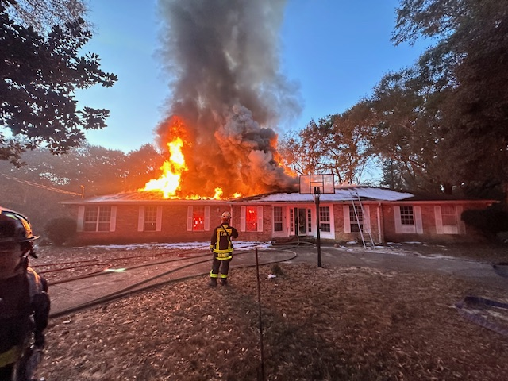

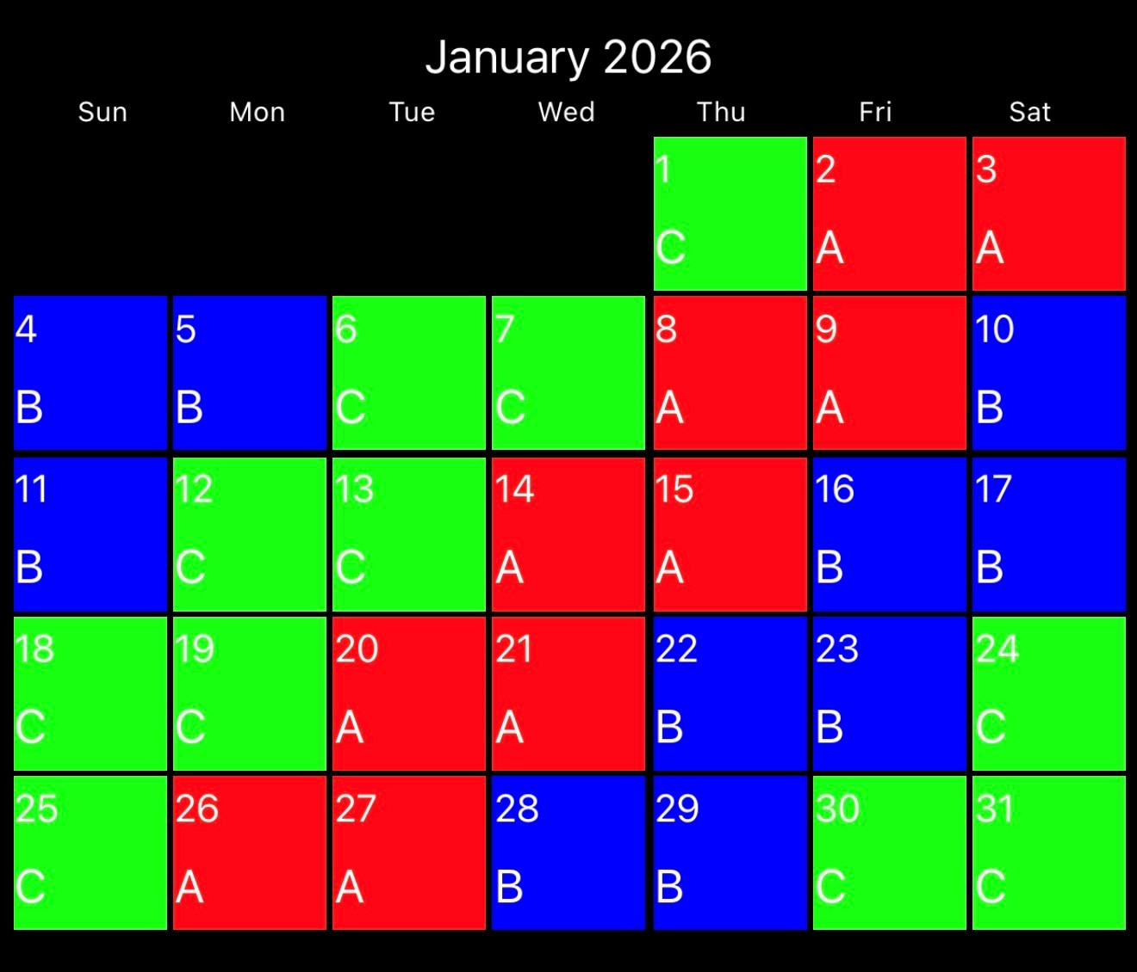
Week 1: SCBA drill and competency
Dates to Remember:
LODD Remembrance: Lt Terrell Jackson- 1/9/2023
January 1: New Years Day (Holiday)
January 19: Martin Luther King, Jr. Day (Holiday)
Quarterly Fire Station Inspections “A” Watch

Week 2: LODD Study- FDNY Black Sunday
Week 3: Significant Fire: NHC Nursing Home Fire, Nashville
Week 4: Building Construction- Sprinkler Systems
Week 5: Officer Selection
Hands On Training- Vent Enter Search (Part 2)
USAR: Vehicle and Machinery Rescue
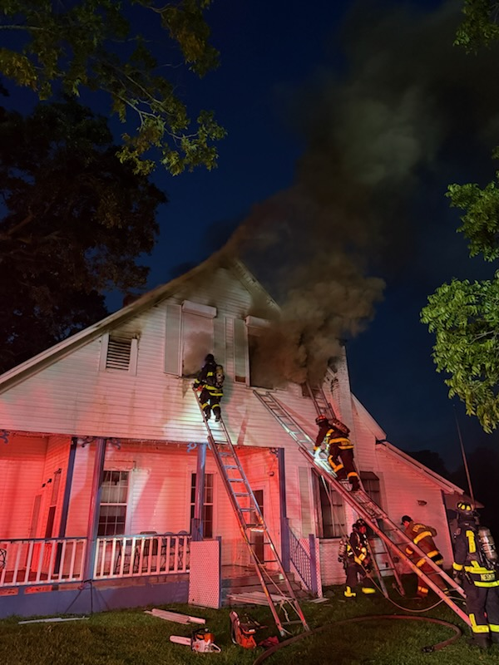

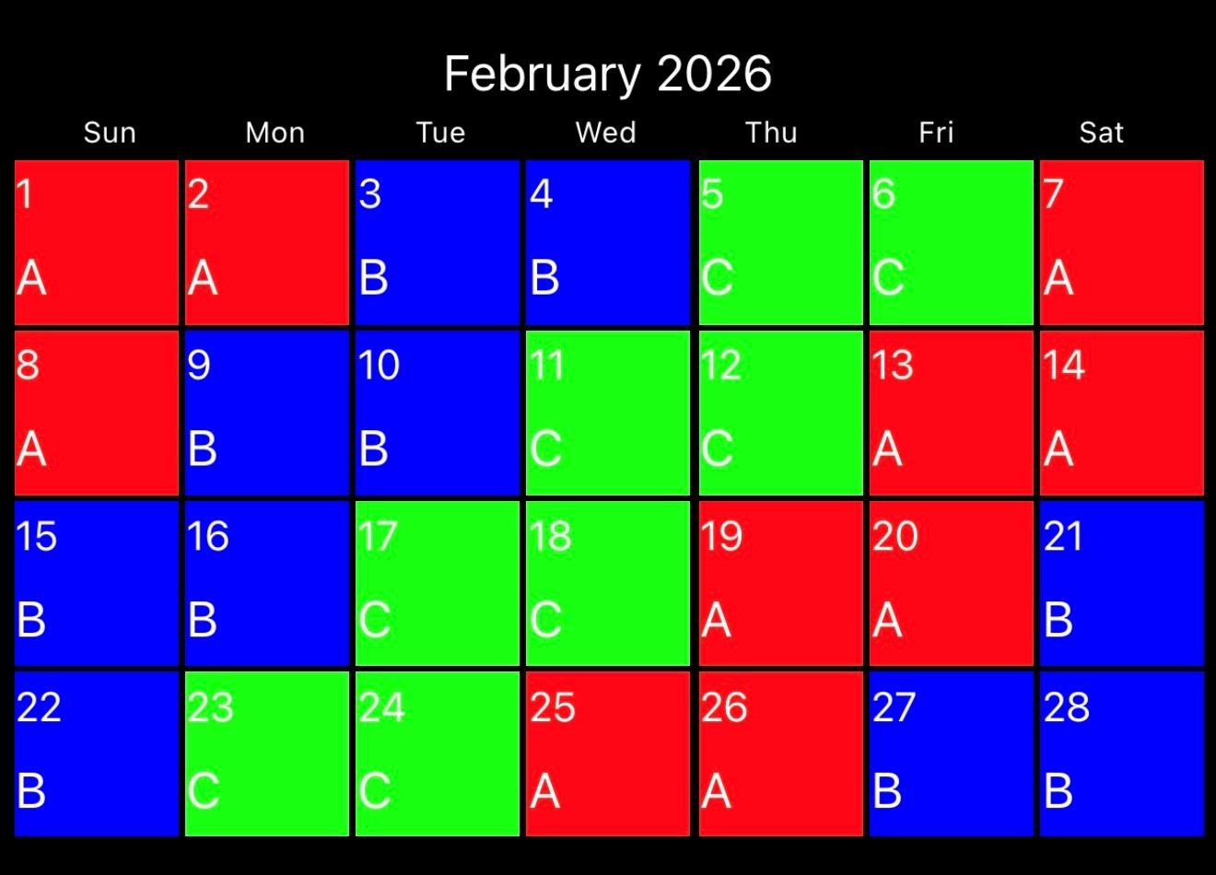
Week 1: High Rise Deployments
Dates to Remember:
February 2, 3, 5, 9, 11, 13: Hazmat Training
February 10 or 12: EMS In-Service
February 14: ECFR Fire Academy Class 2025-1 Graduation
February 16: Presidents Day (Holiday)
February 21: ECFR Medal Day

Week 2: Firefighter CPR
Week 3: LODD Study- One Meridian Plaza
Week 4: Significant Fire: The Station Nightclub
Online Class: RT-130: Annual Wildland Fire Safety Refresher - Module 1 (2933418)
USAR: Confined Space
Hazmat: Quarterly Training- PPE, Communications and Decon
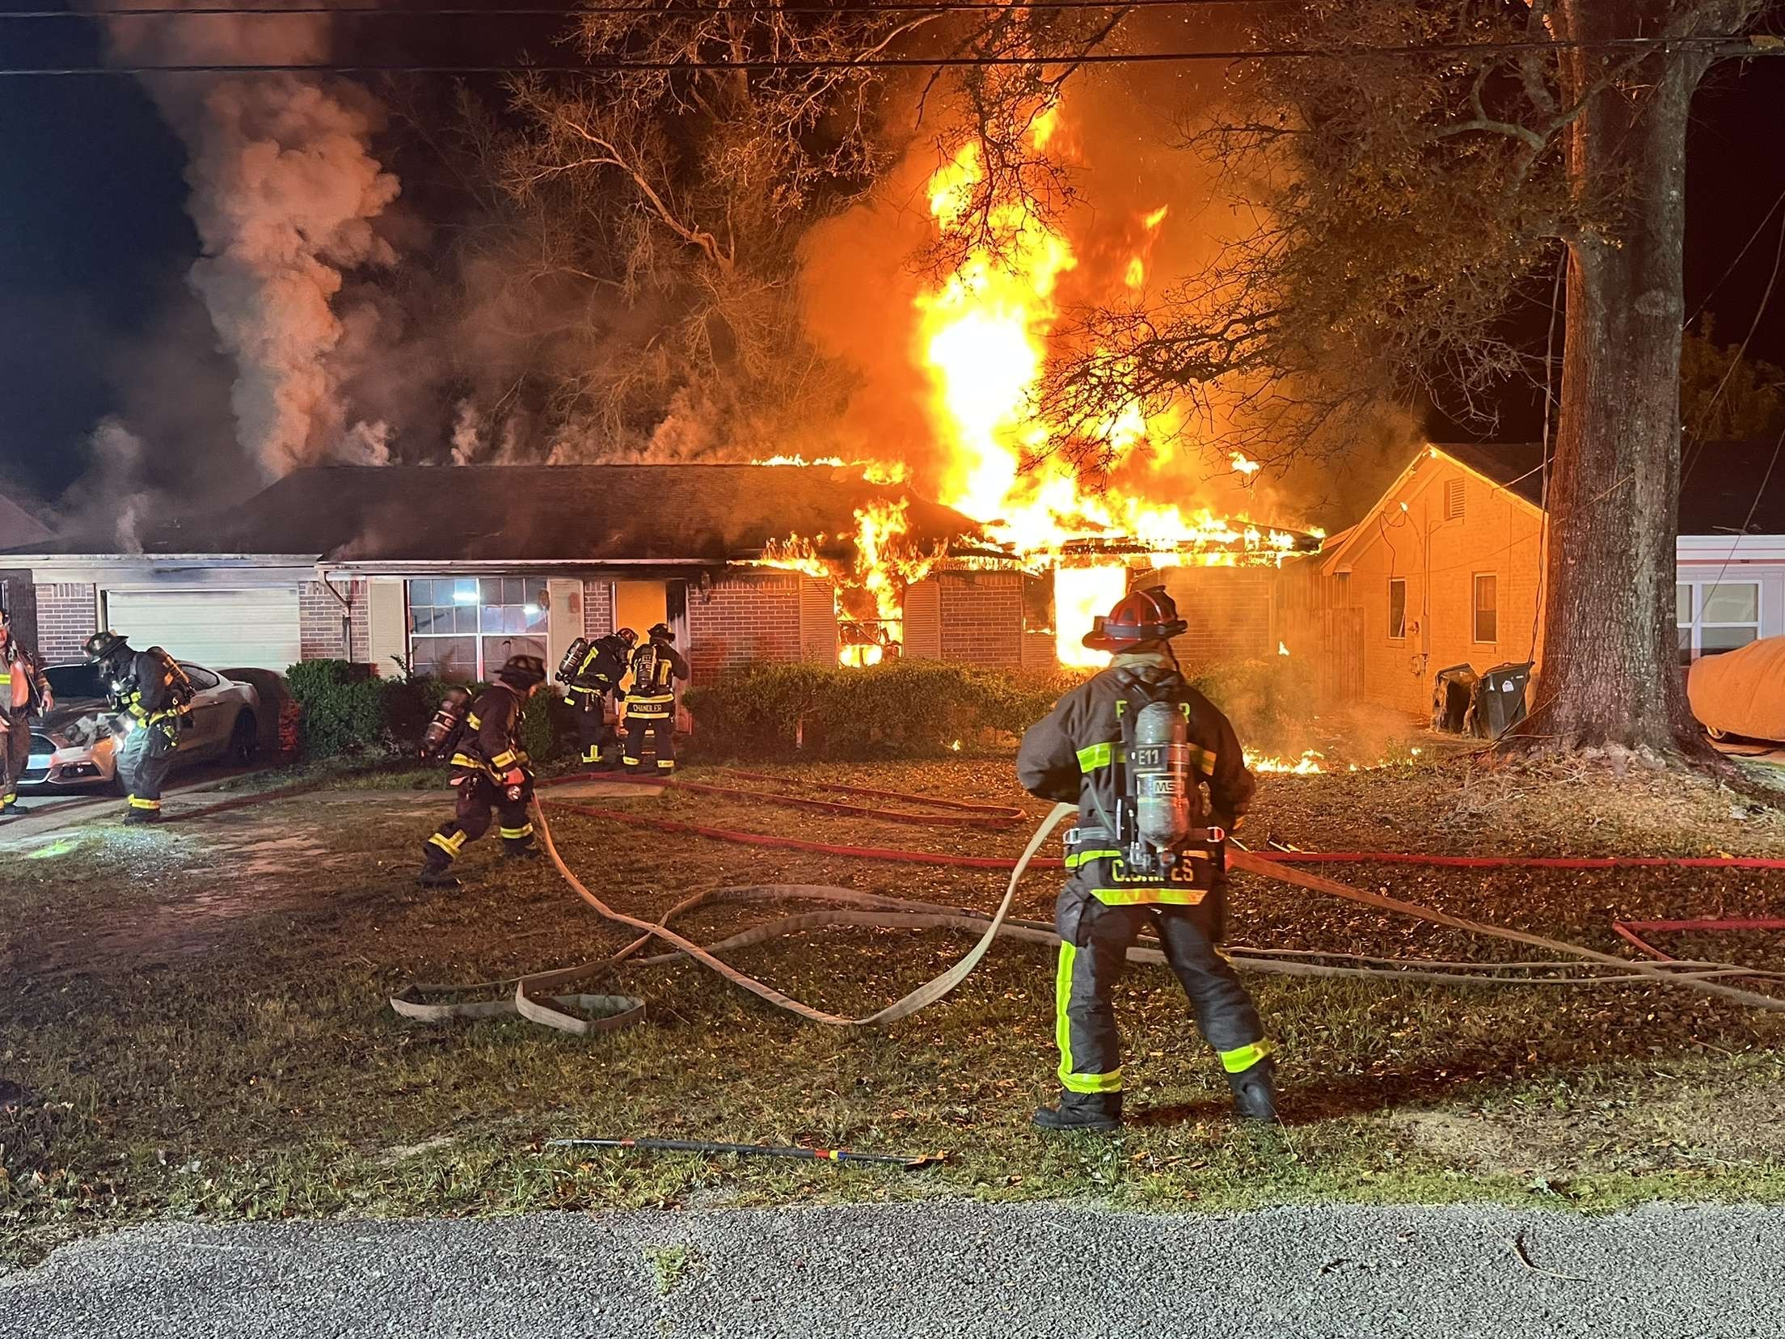

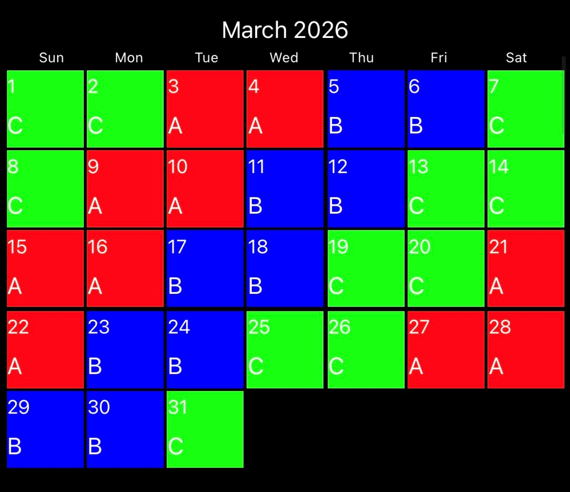
Week 1: Fire Behavior- Wind Driven Fires
Dates to remember:
March 2nd and 3rd- Officer Development Training 0800-1200
March 2nd- Beyond Minimum Standards Class begins

Week 2: Significant Fires: Triangle Shirtwaist Fire
Week 3: Hose Deployments- Extended Stretch
Week 4: LODD Study- Back Bay Fire, Boston
Week 5: Officers Selection
HOT: SCBA Confidence Course
USAR: Structural Collapse

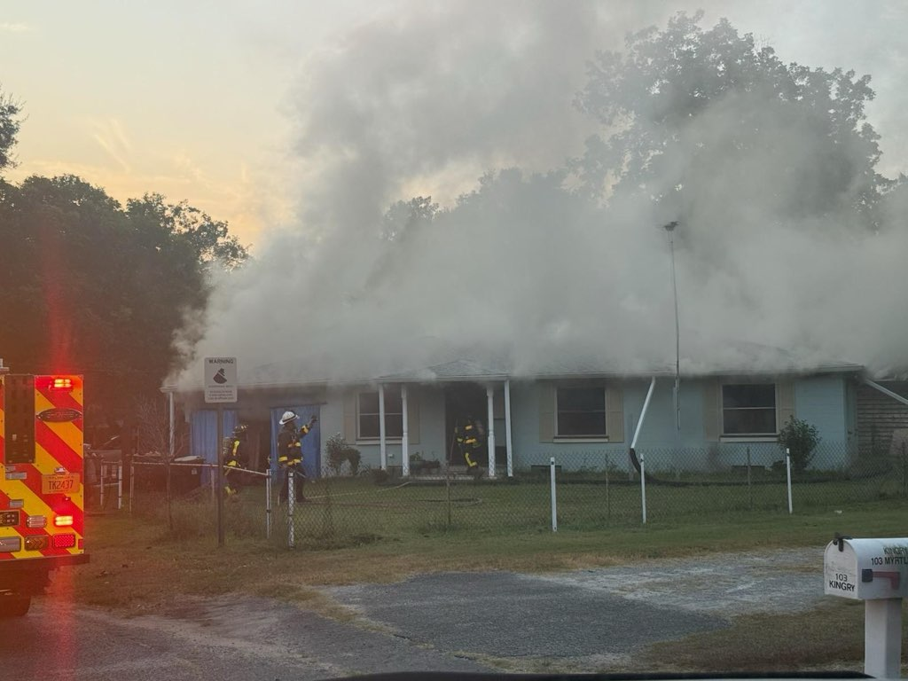

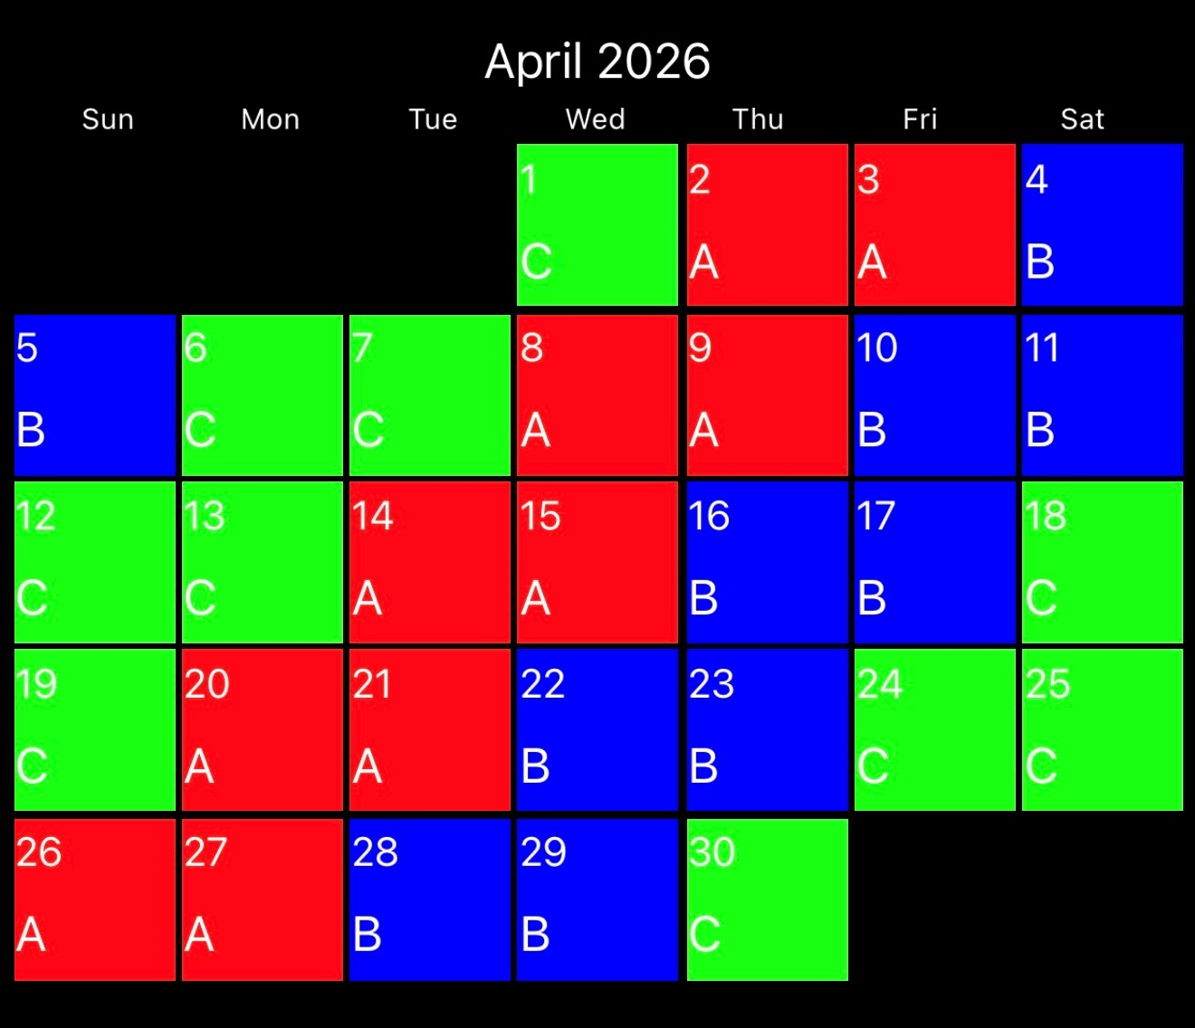

Week 1: Water Supply: Hydrants
Dates to Remember:
April 3rd: Good Friday (Holiday)
April 10th: Last Day of BMSC
April 14th or 16th: EMS In-Service
Quarterly Station Inspections (B Watch)
Week 2: LODD- Buffalo Fire Department Propane Explosion
Week 3: Gas Detection and Meters
Week 4: New London, Texas School Explosion
On-Line Course: EMS Carbon Monoxide Poisoning (51514)
USAR: Trench Rescue

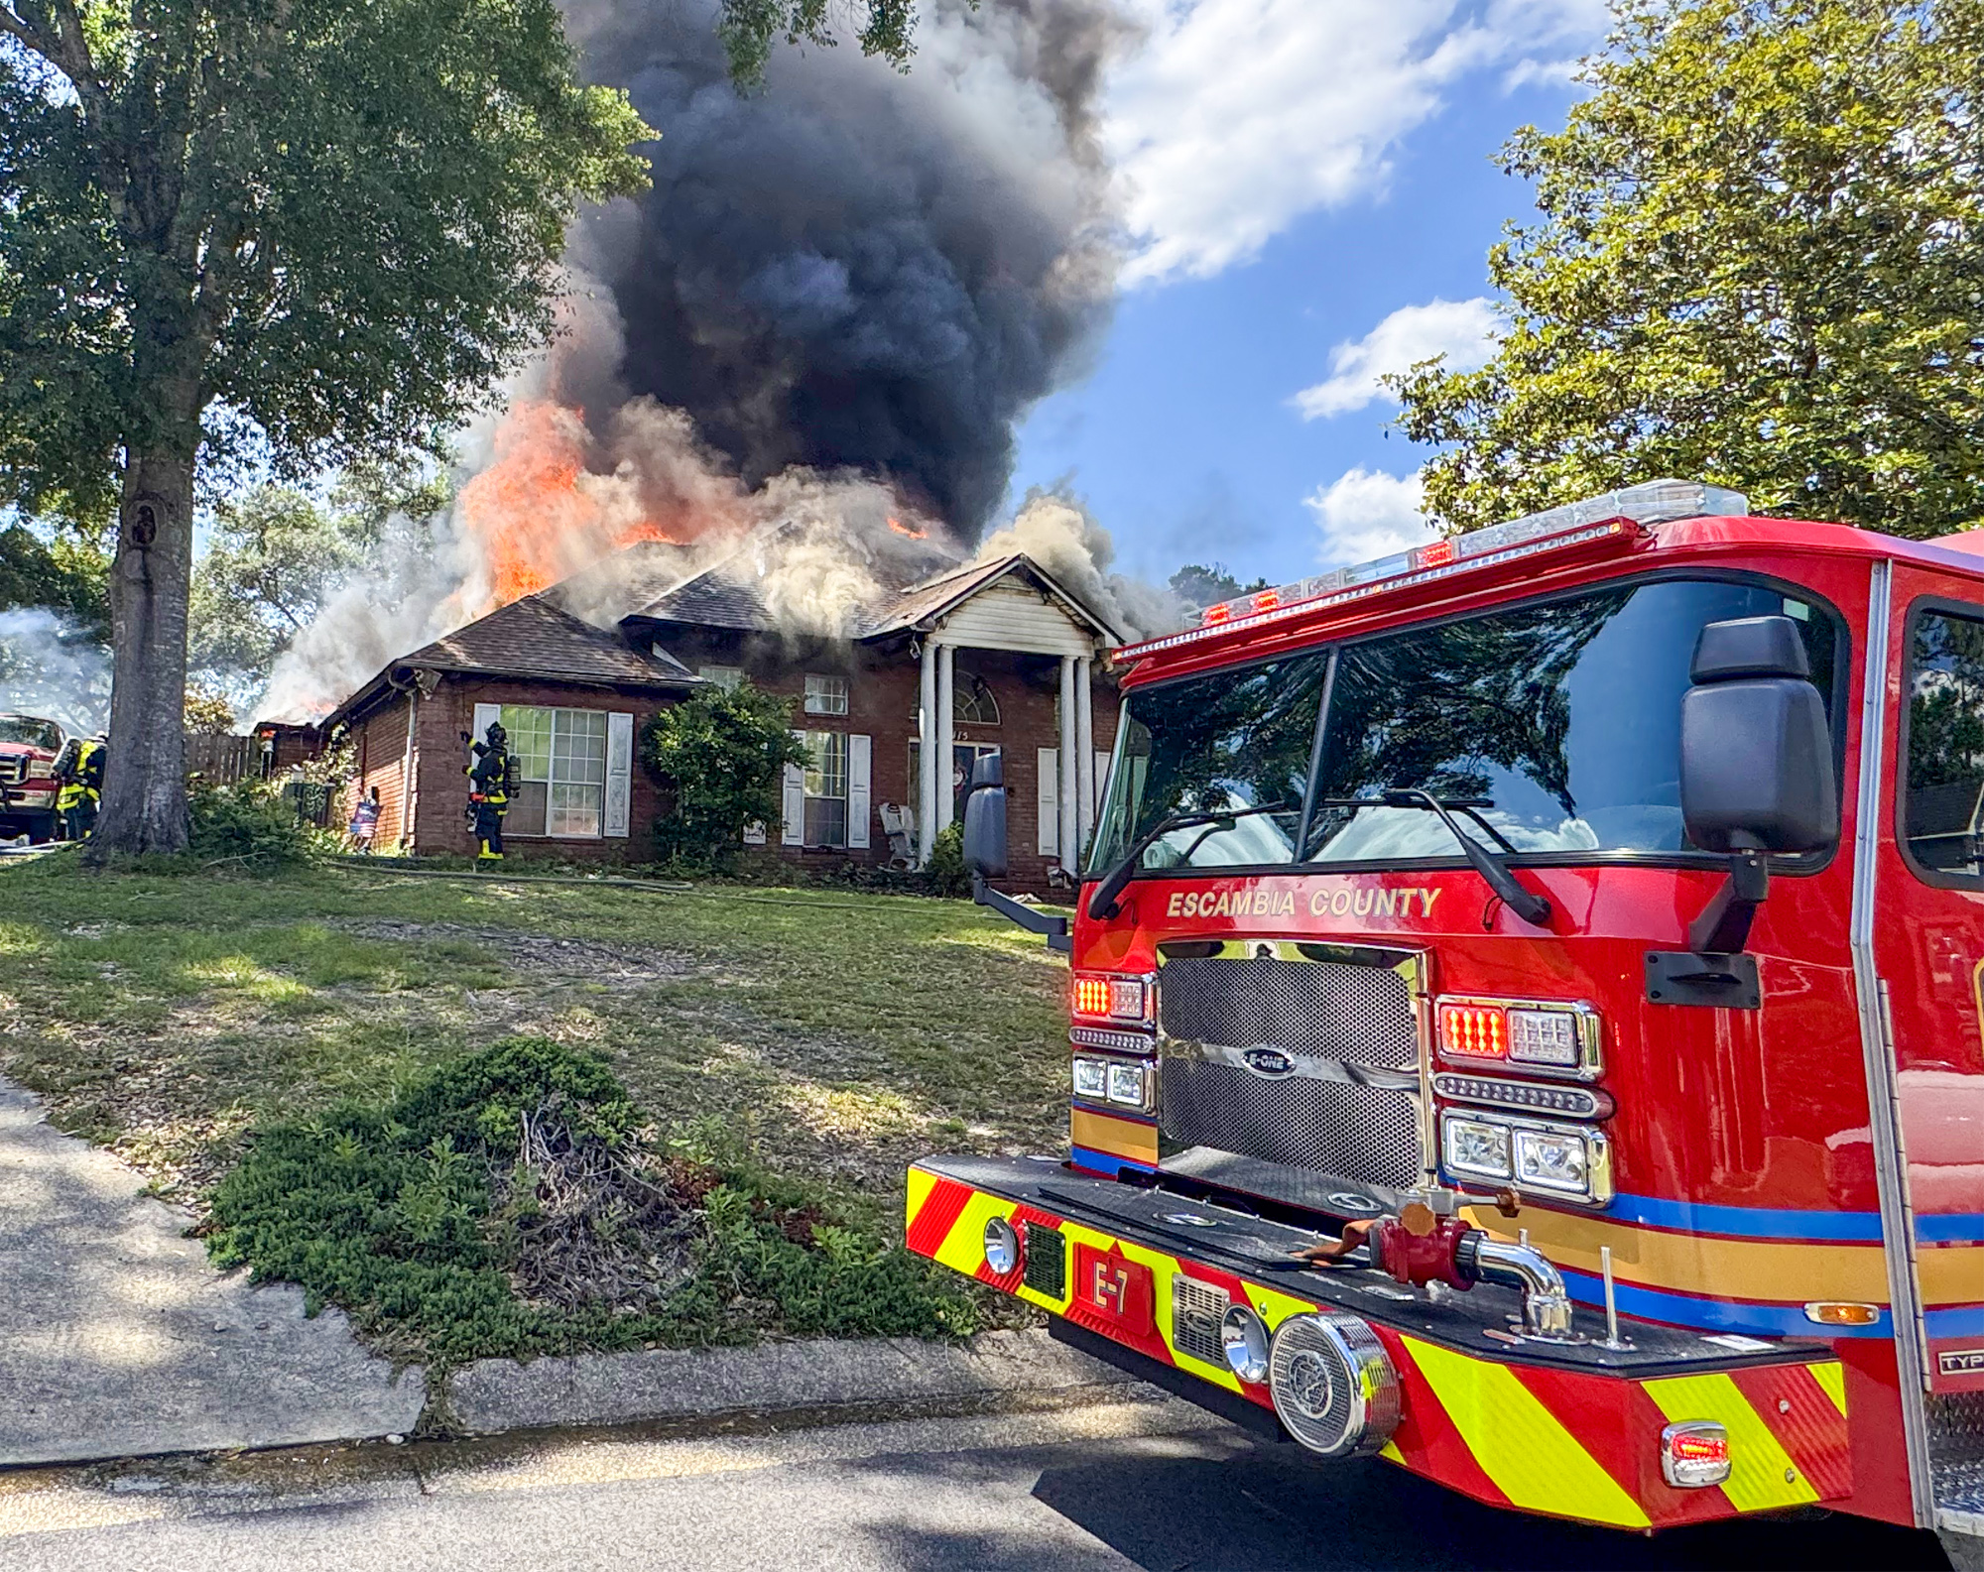

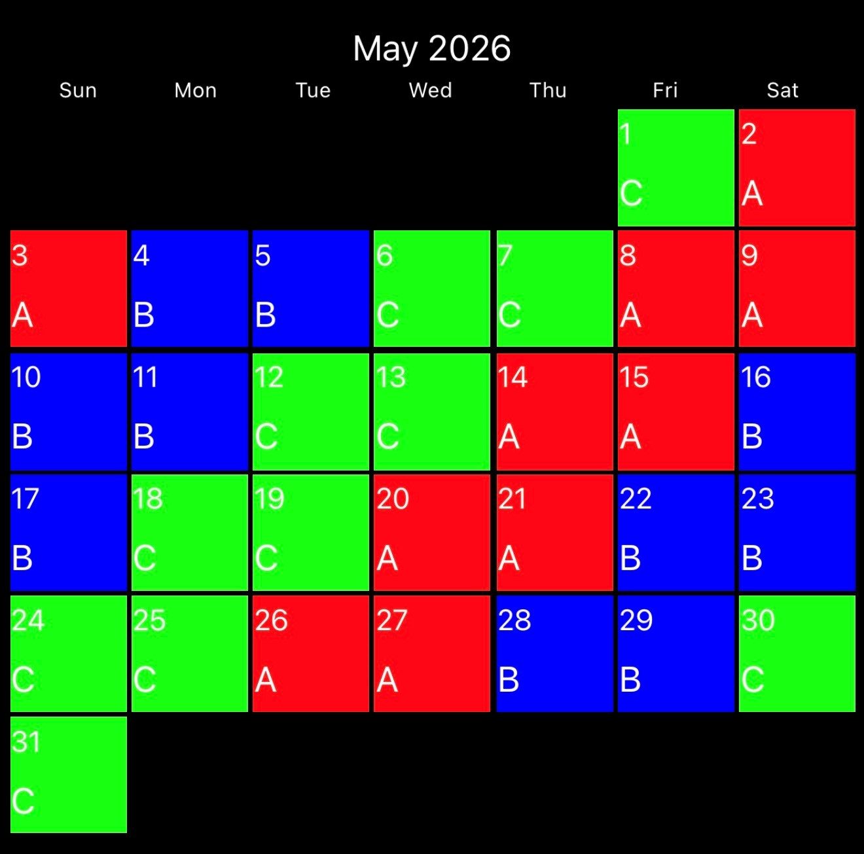
Week 1: Large Flow Lines- Offensive
Dates to Remember:
May 4, 6, 8, 11, 12, 14: Hazmat Training
May 19th or 20th: Quarterly Officer Development Training
May 25th: Memorial Day (Holiday)

Week 2: LODD- Cherry Street Fire, DCFD
Week 3: Extreme Weather Events- Hurricanes
Week 4: Significant Fire- Boyd Street, LAFD
HOT: EVOC Course
USAR: Rope Rescue
Online Course: RT-130: Annual Wildland Fire Safety Refresher – Module 2 (2933447)
HAZMAT: Quarterly Training- Over the Road Emergencies: Trailers and Saddle tanks

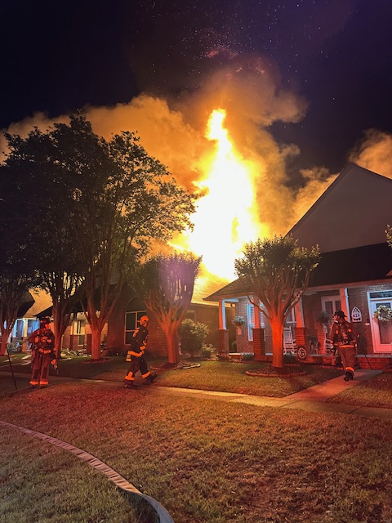

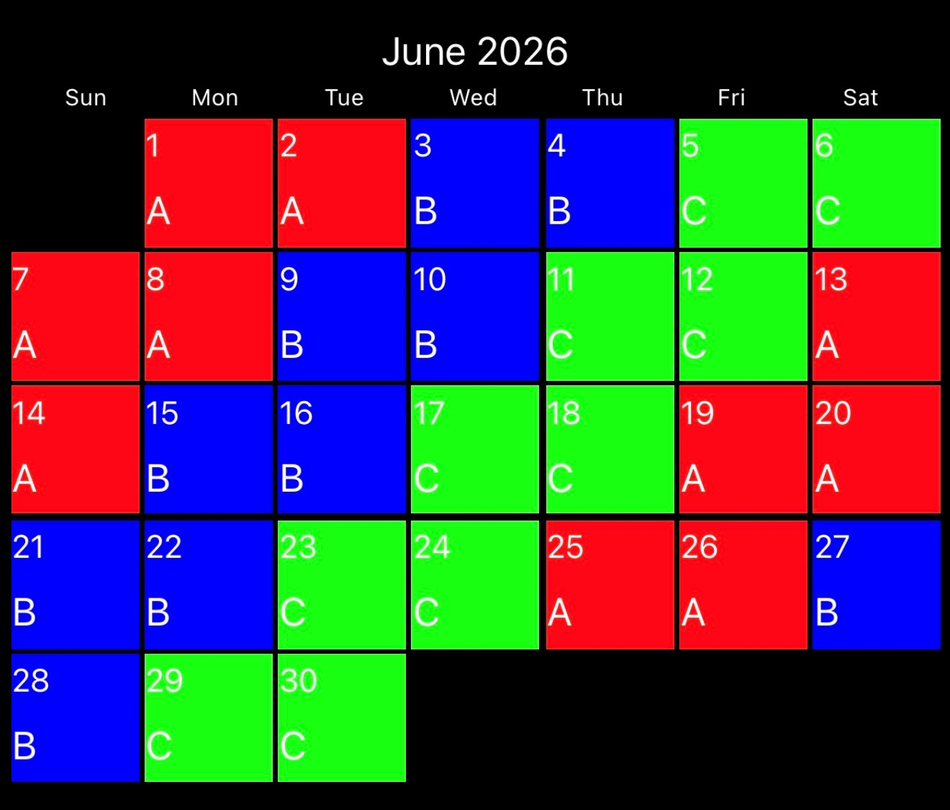
Week 1: Ground Ladders
Dates to Remember:
June 9th or 11th: EMS In-Service
June 19th: Juneteenth (Holiday)

Week 2: LODD- Father’s Day, FDNY
Week 3: Victim Removals- Ground Ladders
Week 4: Significant Fires- Charleston Super Sofa
Week 5: Officer Selection
HOT: Firefighter Survival- Bailouts
USAR: Swiftwater

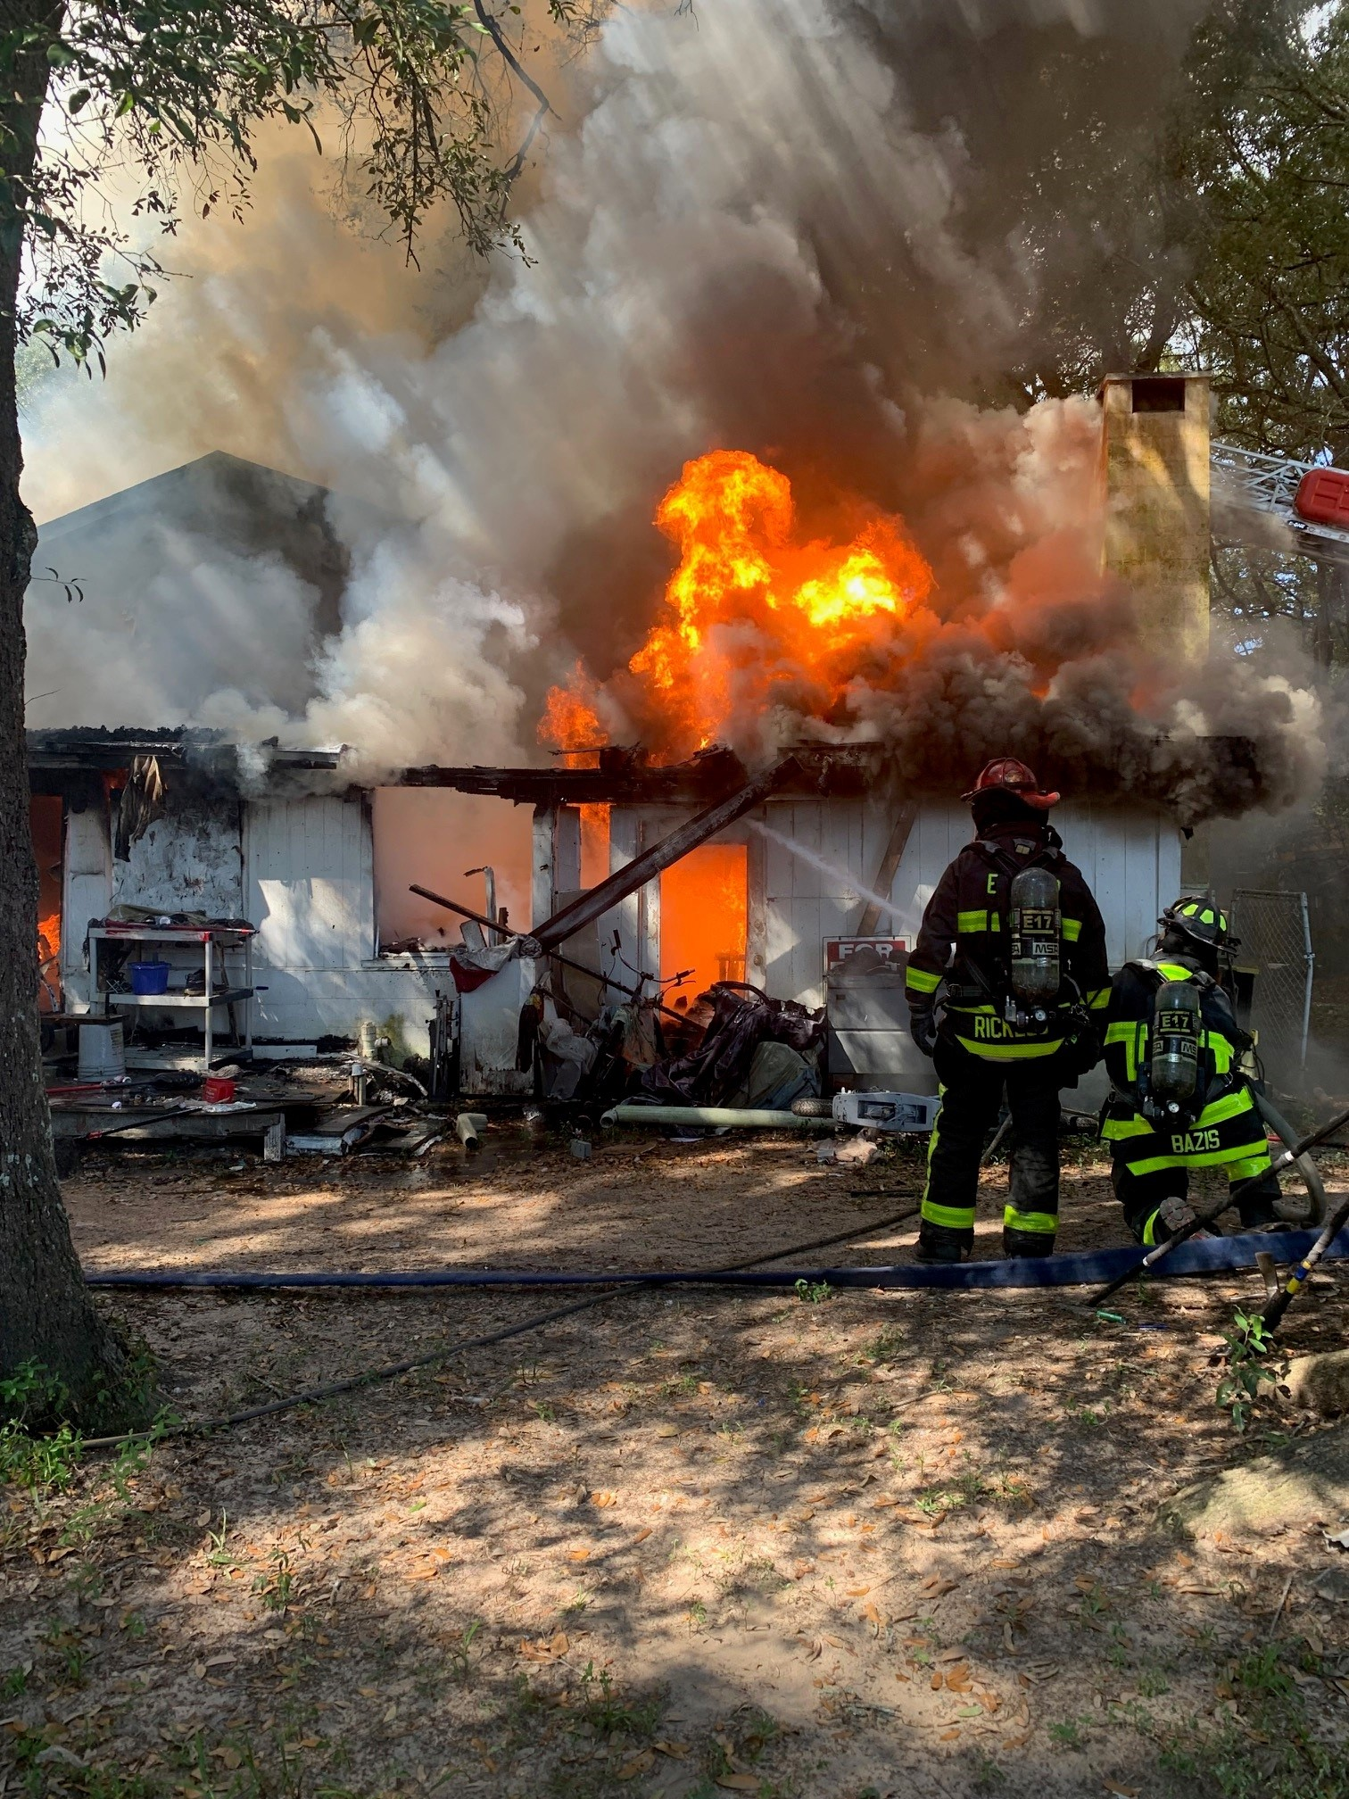

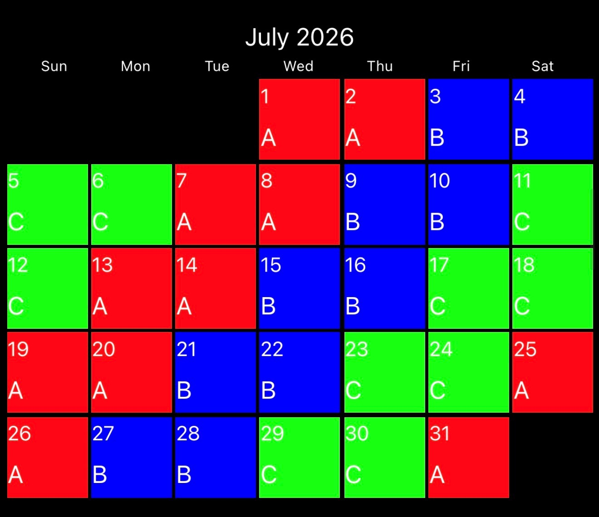
Week 1: Forcible Entry- Residential Doors
Dates to Remember:
July 3: Independence Day (Holiday)
Quarterly Station Inspections (C watch)

Week 2: LODD- Yarnell Wildland Fire
Week 3: Aerial Apparatus Integration
Week 4: Iroquois Theater Fire
HOT: Forcible Entry Props
USAR: Rope Rescue

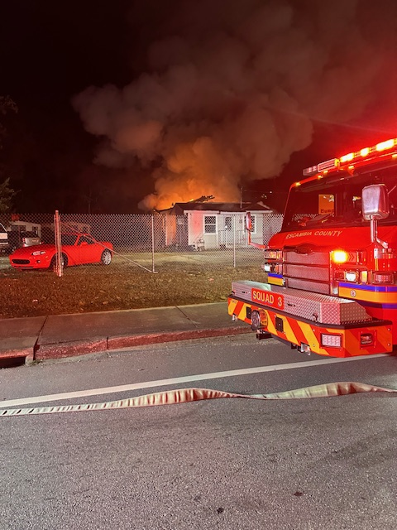

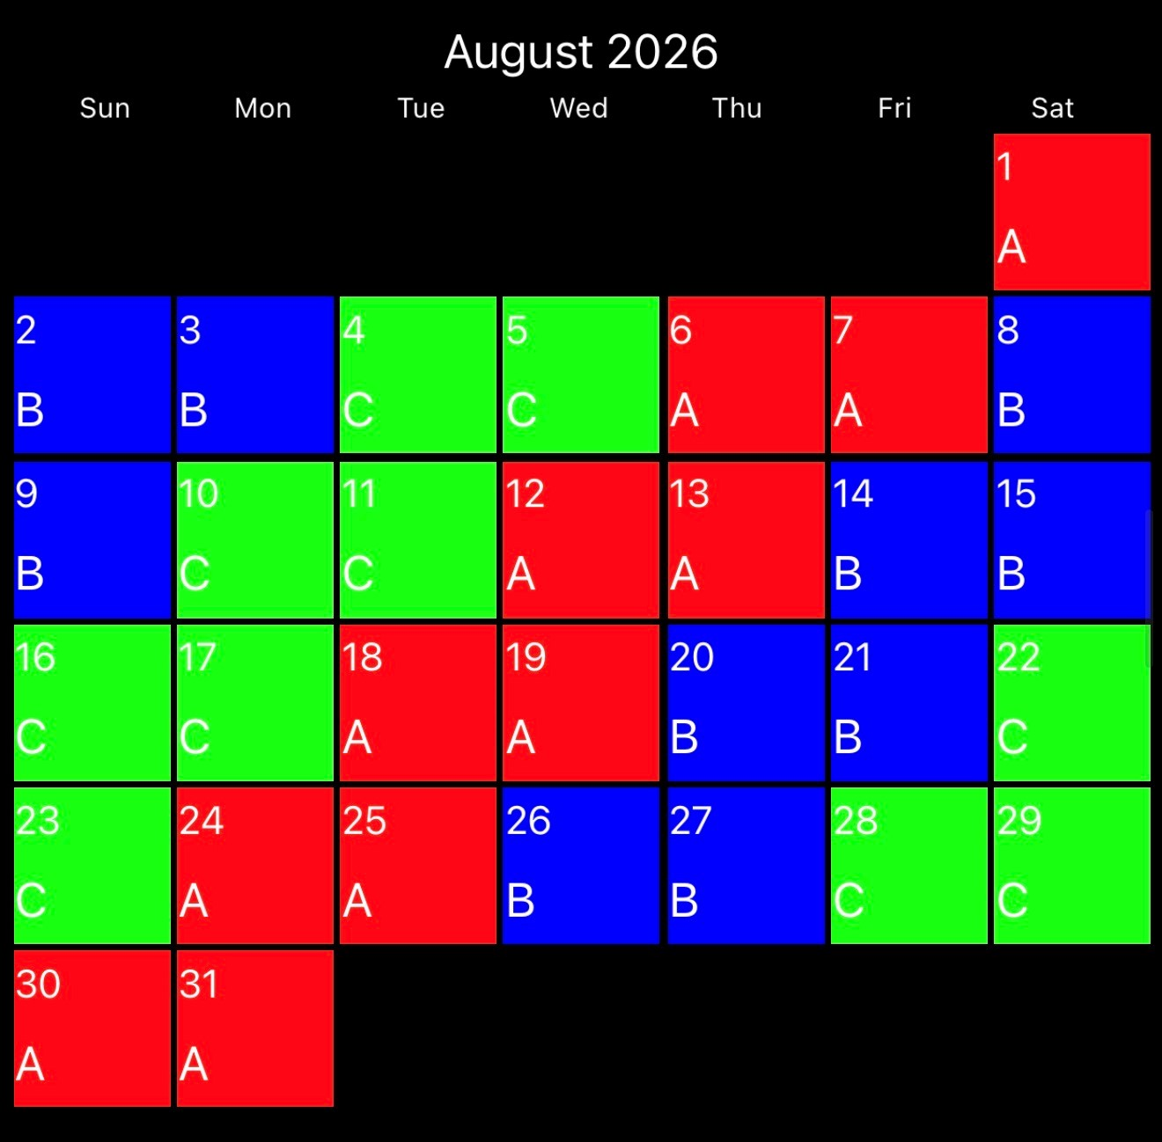
Week 1: Commercial Building Construction
Dates to Remember:
August 11th or 13th: EMS In-Service
August 25th or 26th: Quarterly Officer Development Training
Week 2: LODD- McDonalds Commercial Fire, Houston
Week 3: ASHER Incidents
Week 4: Significant Fires- Our Lady of Angels, Chicago
Online Class: RT-130: Annual Wildland Fire Safety Refresher – Module 3 (2933449)
USAR: Swiftwater Rescue

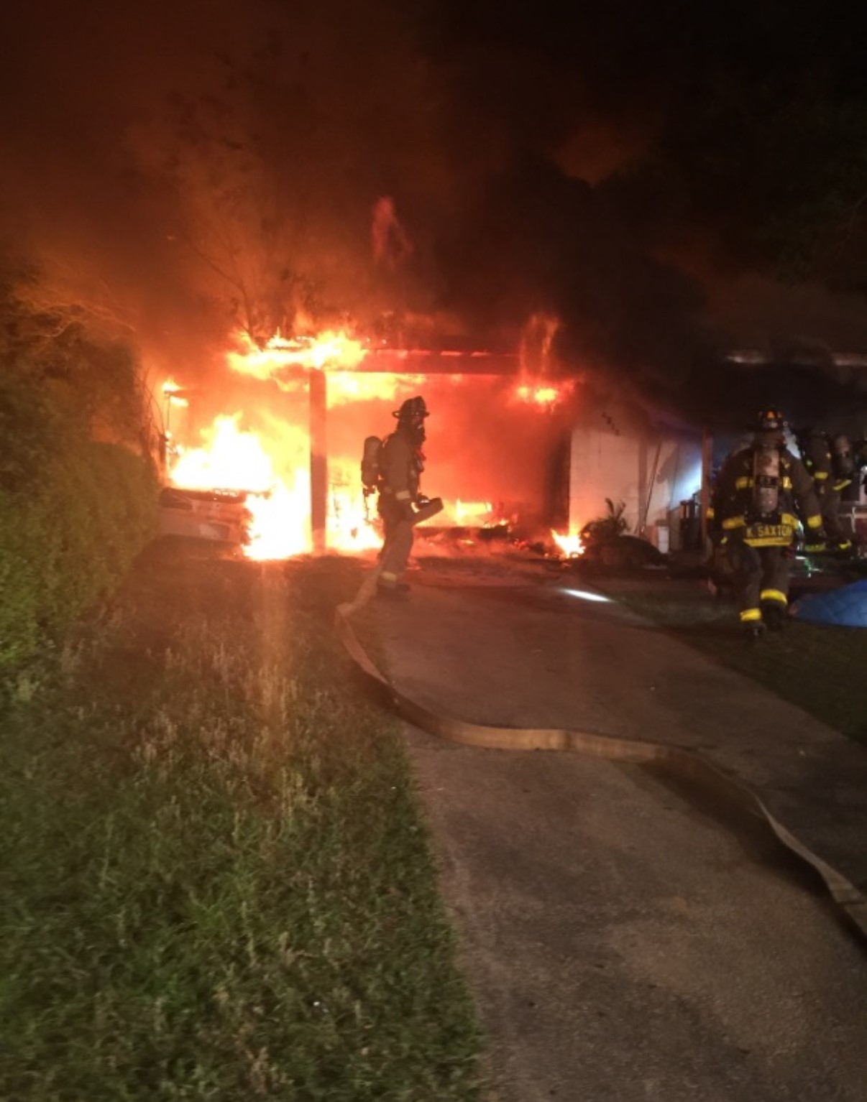

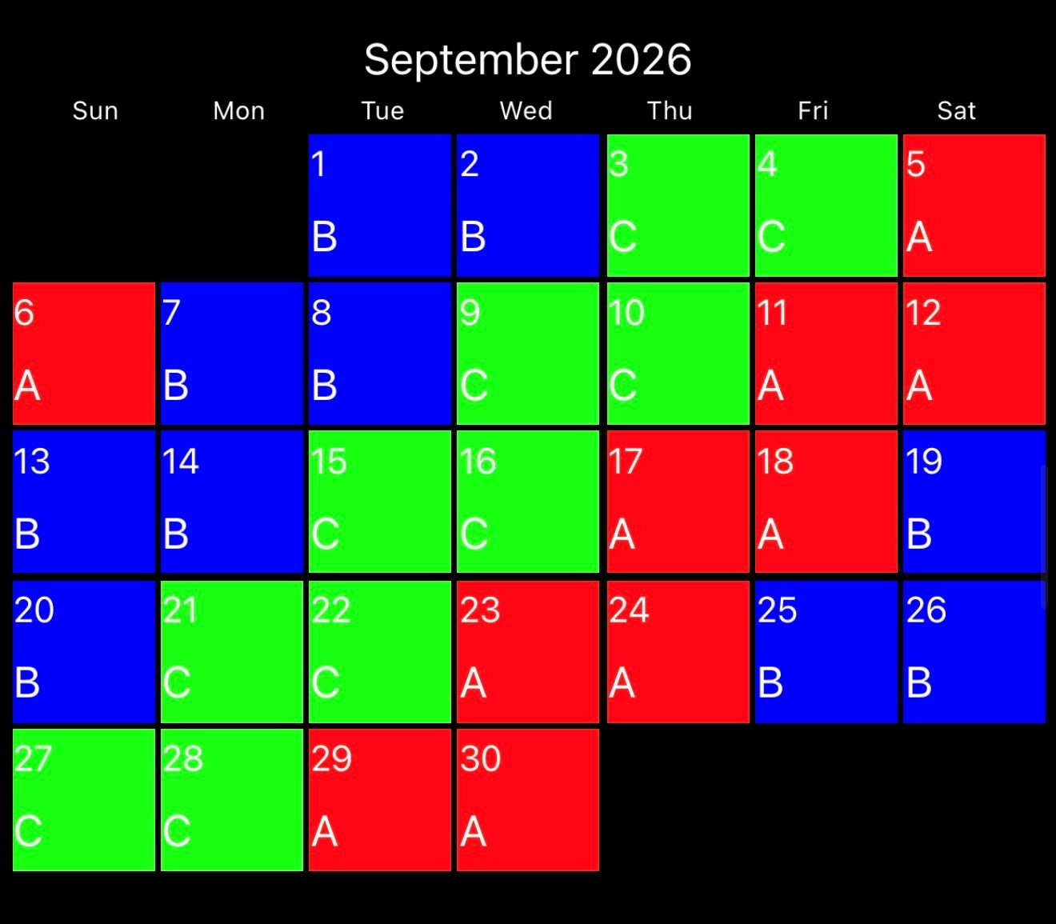
Week 1: Saws: Gas Powered
Dates to Remember:
September 7th: Labor Day (Holiday)
September 7, 9, 11, 14, 16, 17: Hazmat Training

Week 2: LODD- Kevin Bell, Hartford CT
Week 3: Large GPM’s- RAM, Deck Guns, and Aerials
Week 4: Significant Fire: Hartford Circus Fire
Week 5: Fire Prevention Education
Online Class: EMS Trauma Assessment for Head and Neck Injuries (1994461)
USAR: VMR
HAZMAT: Quarterly Training- Research and Identification
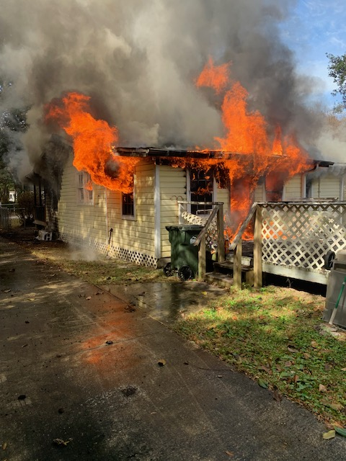

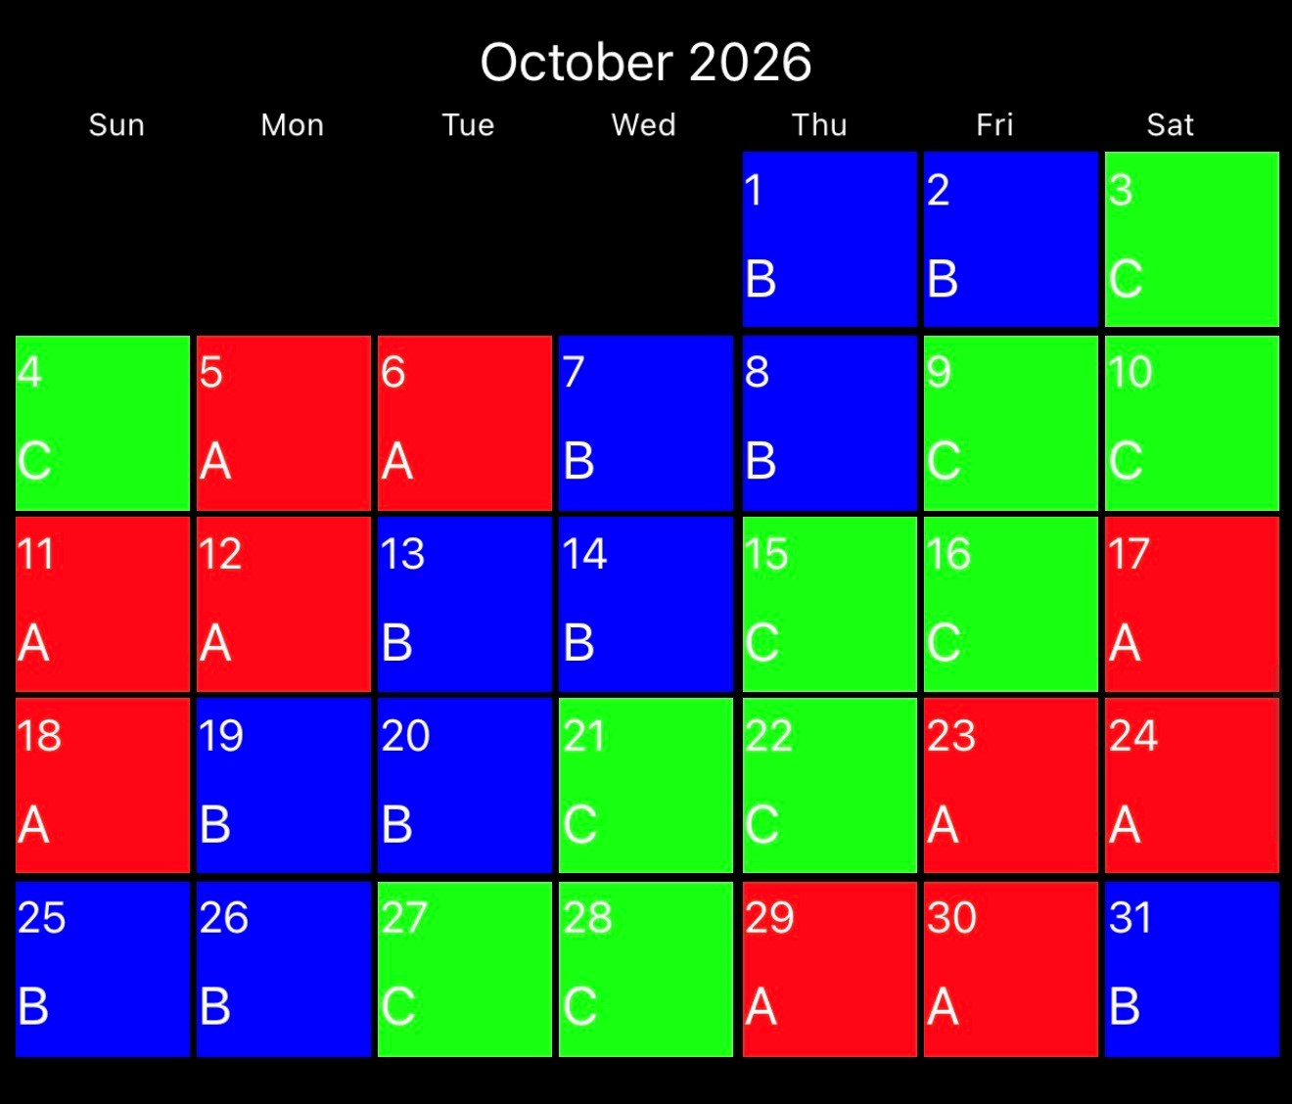
Week 1: Gustin Pack Deployments
Dates to Remember:
October 20th or 22nd: EMS In-Service
Quarterly Station Inspections (B Watch)
EMT and Paramedic Recertifications Due December 1
Week 2: LODD- 23rd Street Fire
Week 3: Commercial Forcible Entry
Week 4: Significant Fire- Coconut Grove Fire
HOT: Roof Props
USAR: Trench Rescue
Online Class: EMS Pediatric Respiratory Emergencies: Upper and Lower Airway for the First Responder (1318497)

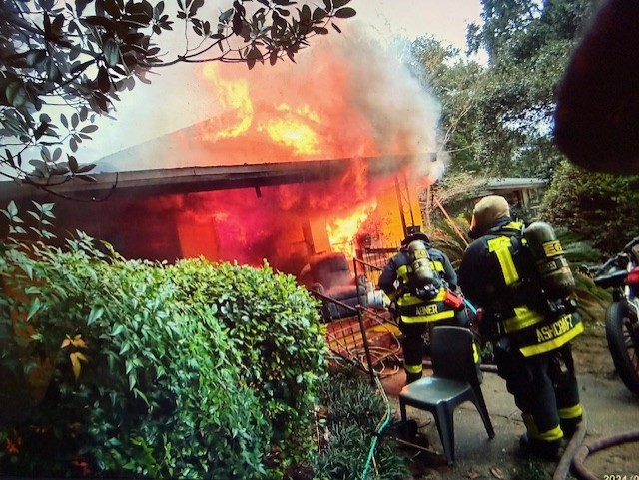

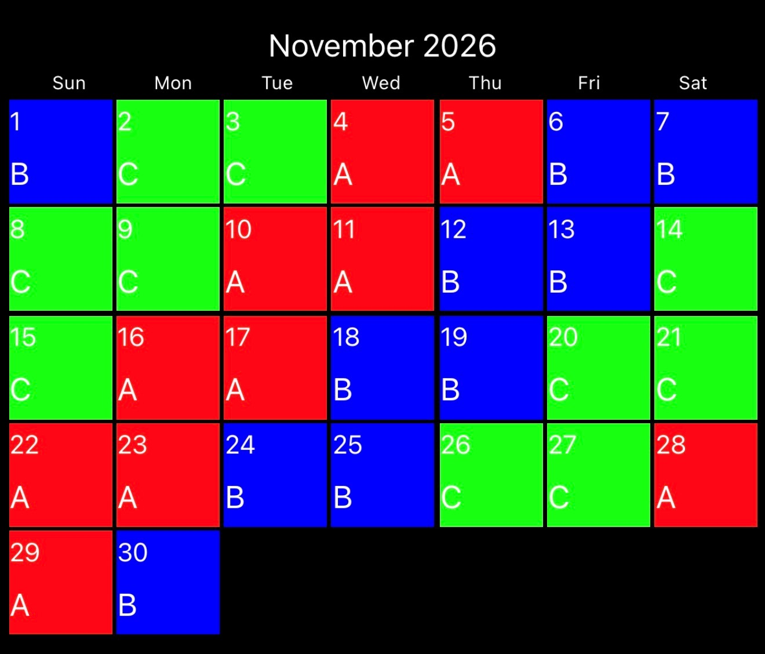
Week 1: Rapid Intervention: Packaging/Removal
Dates to Remember:
LODD Remembrance: Chief Dwain Bradshaw- 11-6-2019
November 11th: Veterans Day (Holiday)
November 17th or 18th: Quarterly Officer Development Training
November 26th and 27th: Thanksgiving Day (Holiday)
EMT and Paramedic Recertifications Due December 1

Week 2: LODD- Southwest Supermarket Fire
Week 3: Search Rope Management
Week 4: Significant Fire: Winecoff Hotel Fire, ATL
Online Course: EMS Environmental Emergencies (2918816)
USAR: Confined Space

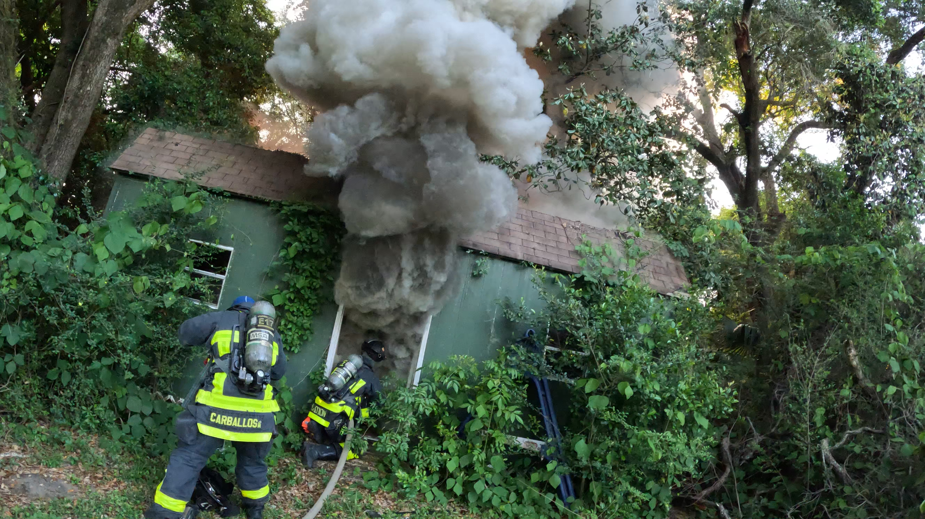

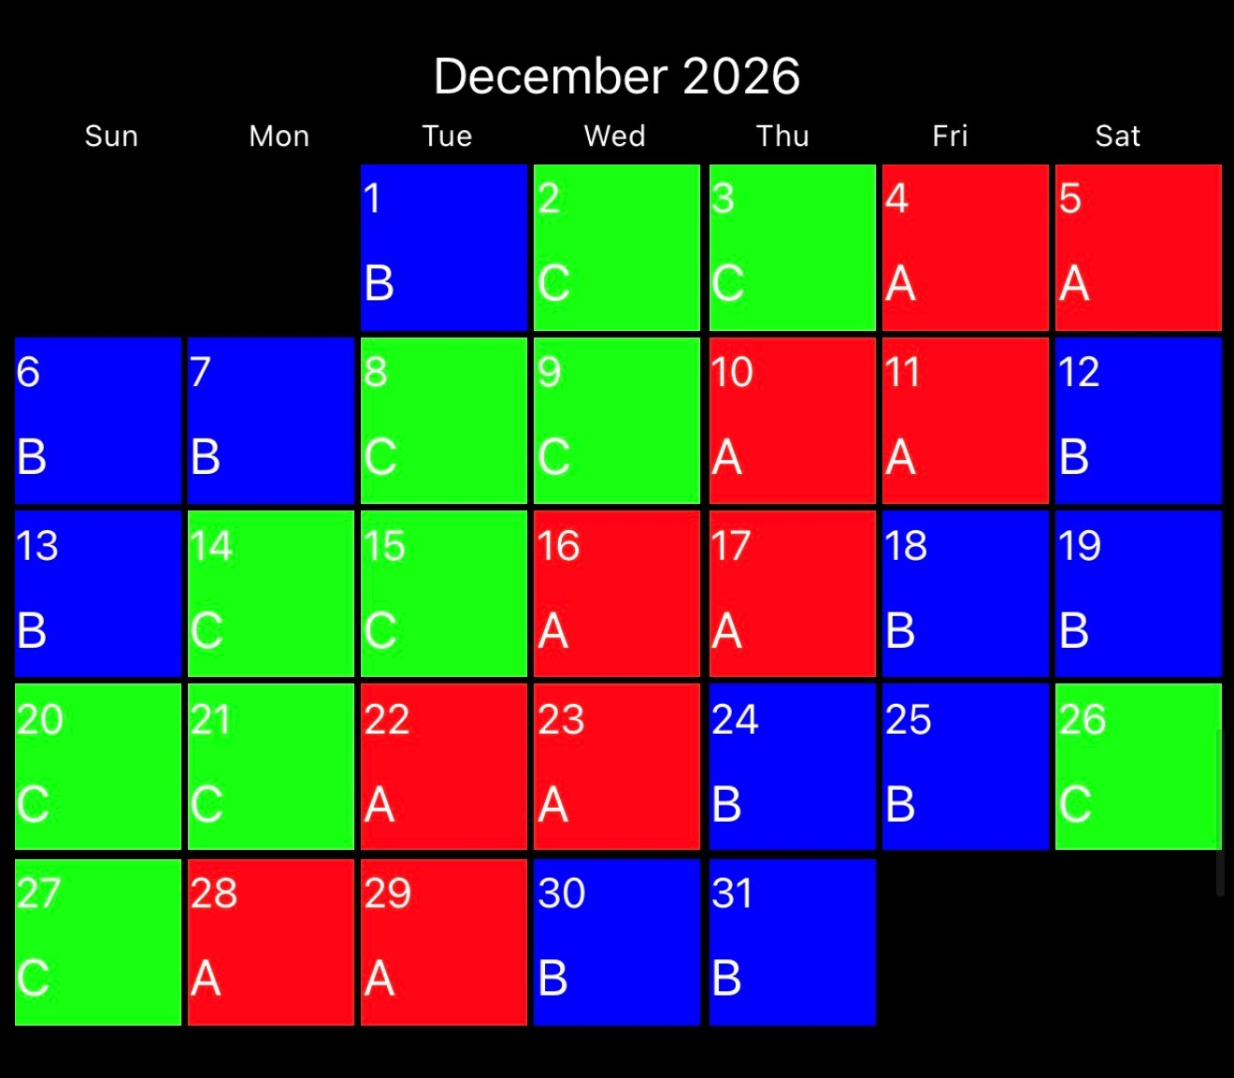
Week 1: Rapid Intervention- Air Supply
Dates to Remember:
December 1, 2, 4, 7, 9, 11- Hazmat Training
December 24th and 25th: Christmas (Holiday)
December 31st: New Years Eve (Holiday)
Week 2: LODD- Vandalia Ave. Fire, FDNY
Week 3: Search and Rescue: Victim Removal
Week 4: Significant Fire- Kiokuk, Iowa
Week 5: Officer Selection
Online Class: RT-130: Annual Wildland Fire Safety Refresher – Module 4 (2933450)
USAR: Structural Collapse
HAZMAT: Quarterly Training- Scenarios

